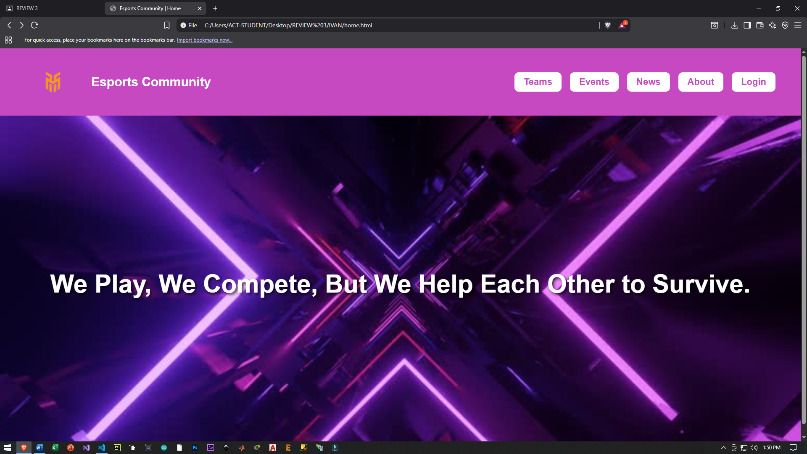
The navigation bar when first visited or doesn’t have an existing account will change to “Sign up”
Code:
<!DOCTYPE html>
<html>
<head>
<title>Esports Community | Home</title>
<style>
body {
font-family: Arial, sans-serif;
margin: 0;
}

header {
background-color: #c749c1;
padding: 20px 50px;
display: flex;
align-items: center;
height: 120px;
}

header img {
height: 80px;
}

.logo-text {
color: white;
font-size: 30px;
font-weight: bold;
margin-left: 15px;
}

nav {
margin-left: auto;
display: flex;
align-items: center;
}

nav a {
background-color: white;
color: #c749c1;
font-size: 22px;
margin: 0 10px;
padding: 10px 22px;
border-radius: 10px;
font-weight: bold;
text-decoration: none;
transition: 0.3s;
}

nav a:hover {
background-color: #ffd700;
}

.banner {
height: 800px;
background: url('background.jpg') center/cover no-repeat;
display: flex;
justify-content: center;
align-items: center;
}

.banner h2 {
font-size: 60px;
color: white;
text-align: center;
text-shadow: 4px 4px 6px rgba(0,0,0,0.7);
}
</style>
</head>

<body>
<header>
<img src="logo.png" alt="Esports Community Logo">
<div class="logo-text">Esports Community</div>

<nav>
<a href="#">Teams</a>
<a href="#">Events</a>
<a href="#">News</a>
<a href="#">About</a>

<!-- Auth navigation -->
<a href="signup.html" id="signupNav">Sign Up</a>
<a href="login.html" id="loginNav" style="display:none;">Login</a>
</nav>
</header>

<div class="banner">
<h2>We Play, We Compete, But We Help Each Other to Survive.</h2>
</div>

<script>
// Account existence check (persistent)
const hasAccount = localStorage.getItem("hasAccount");

if (hasAccount === "true") {
document.getElementById("signupNav").style.display = "none";
document.getElementById("loginNav").style.display = "inline-block";
} else {
document.getElementById("signupNav").style.display = "inline-block";
document.getElementById("loginNav").style.display = "none";
}
</script>
</body>
</html>

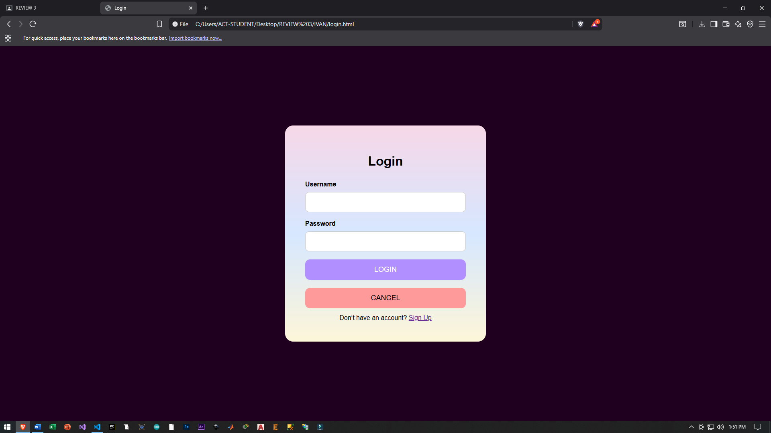
CODE:
<!DOCTYPE html>
<html>
<head>
<title>Login</title>
<style>
body {
background: #20001f;
font-family: "Poppins", sans-serif;
margin: 0;
height: 100vh;
display: flex;
justify-content: center;
align-items: center;
}

.login-container {
width: 400px;
padding: 50px;
border-radius: 20px;
background: linear-gradient(#f7d8e8, #d6e7ff, #fdf6d9);
box-shadow: 0 0 20px rgba(0,0,0,0.15);
}

h1 {
text-align: center;
margin-bottom: 30px;
}

label {
font-weight: 600;
display: block;
margin-top: 20px;
}

input {
width: -webkit-fill-available;
padding: 15px;
border-radius: 10px;
border: 1px solid #ccc;
font-size: 16px;
margin-top: 10px;
}

button {
width: 100%;
padding: 15px;
margin-top: 20px;
border-radius: 12px;
border: none;
font-size: 18px;
cursor: pointer;
}

.login-btn {
background: #b28fff;
color: #fff;
}

.cancel-btn {
background: #ff9a9a;
}

.error {
color: red;
margin-top: 15px;
text-align: center;
}

.small-text {
text-align: center;
margin-top: 15px;
}
</style>
</head>

<body>
<div class="login-container">
<h1>Login</h1>

<form id="loginForm">
<label>Username</label>
<input type="text" id="username" required>

<label>Password</label>
<input type="password" id="password" required>

<button type="submit" class="login-btn">LOGIN</button>
<button type="button" class="cancel-btn" id="cancelBtn">CANCEL</button>

<div class="error" id="errorMsg"></div>

<div class="small-text">
Don’t have an account? <a href="signup.html">Sign Up</a>
</div>
</form>
</div>

<script>
document.getElementById("loginForm").addEventListener("submit", function (e) {
e.preventDefault();

const inputUser = document.getElementById("username").value;
const inputPass = document.getElementById("password").value;

const storedUser = localStorage.getItem("username");
const storedPass = localStorage.getItem("password");

if (inputUser === storedUser && inputPass === storedPass) {
alert("You have successfully logged in.");
window.location.href = "https://sams.act.edu.ph/Home/Index"
} else {
document.getElementById("errorMsg").textContent =
"Invalid username or password.";
}
});

document.getElementById("cancelBtn").addEventListener("click", function () {
window.location.href = "home.html";
});
</script>
</body>
</html>

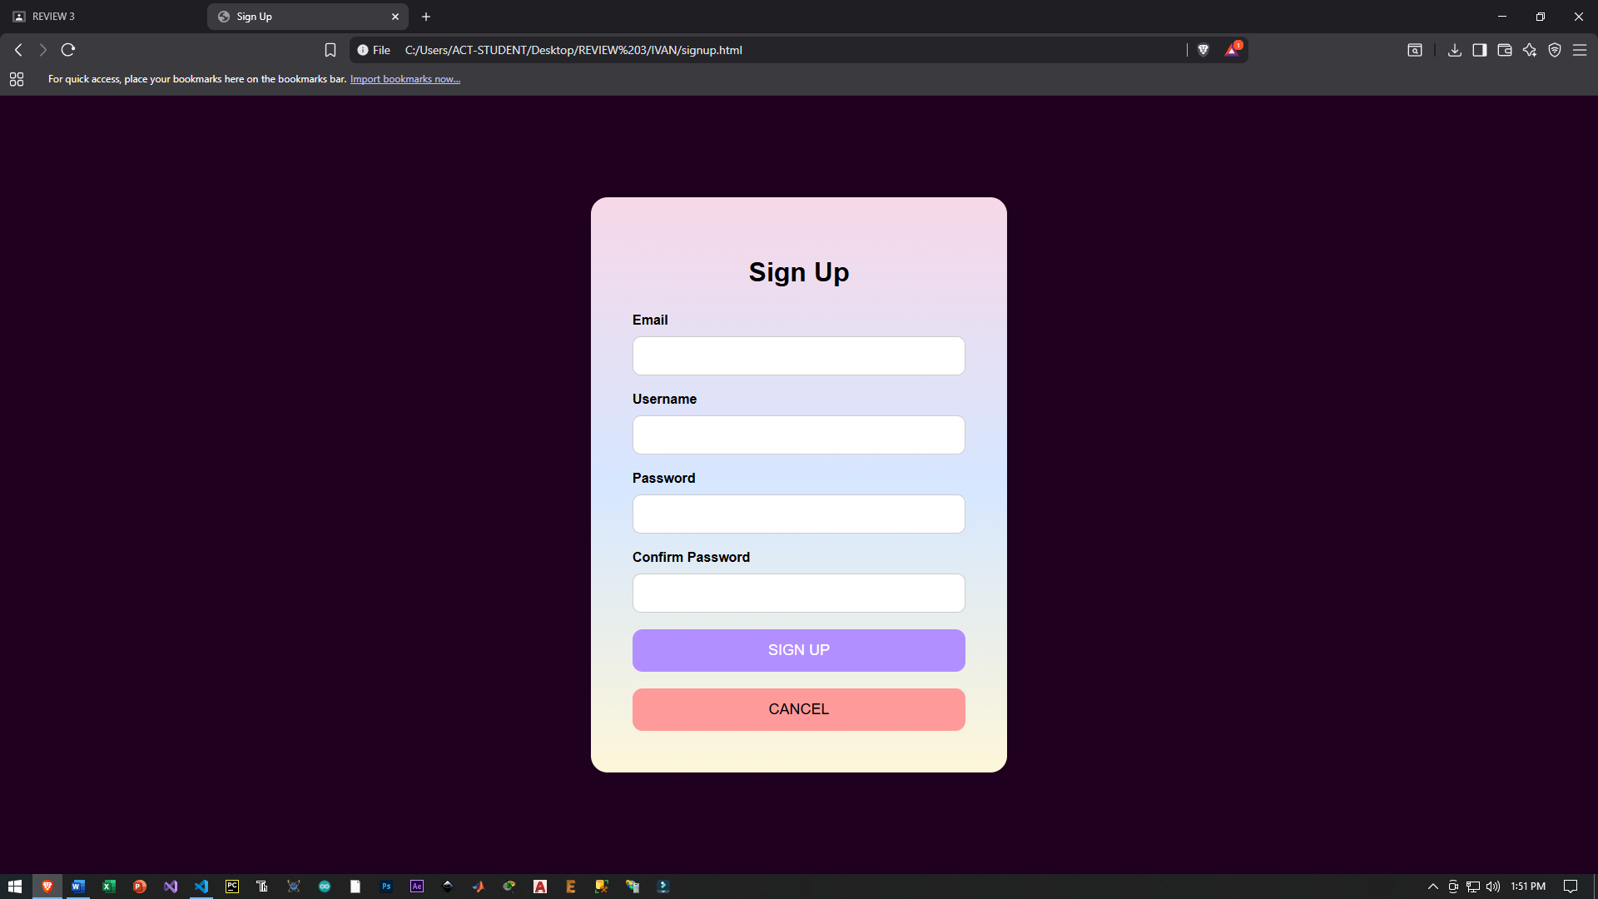
CODE:
<!DOCTYPE html>
<html>
<head>
<title>Sign Up</title>
<style>
body {
background: #20001f;
font-family: "Poppins", sans-serif;
margin: 0;
height: 100vh;
display: flex;
justify-content: center;
align-items: center;
}

.login-container {
width: 400px;
padding: 50px;
border-radius: 20px;
background: linear-gradient(#f7d8e8, #d6e7ff, #fdf6d9);
box-shadow: 0 0 20px rgba(0,0,0,0.15);
}

h1 {
text-align: center;
margin-bottom: 30px;
}

label {
font-weight: 600;
display: block;
margin-top: 20px;
}

input {
width: -webkit-fill-available;
padding: 15px;
border-radius: 10px;
border: 1px solid #ccc;
margin-top: 10px;
}

button {
width: 100%;
padding: 15px;
margin-top: 20px;
border-radius: 12px;
border: none;
font-size: 18px;
cursor: pointer;
}

.signup-btn {
background: #b28fff;
color: white;
}

.cancel-btn {
background: #ff9a9a;
}
</style>
</head>

<body>
<div class="login-container">
<h1>Sign Up</h1>

<form id="signupForm">
<label>Email</label>
<input type="email" id="email" required>

<label>Username</label>
<input type="text" id="username" required>

<label>Password</label>
<input type="password" id="password" required>

<label>Confirm Password</label>
<input type="password" id="confirmPassword" required>

<button type="submit" class="signup-btn">SIGN UP</button>
<button type="button" class="cancel-btn" id="cancelBtn">CANCEL</button>
</form>
</div>

<script>
document.getElementById("signupForm").addEventListener("submit", function (e) {
e.preventDefault();

const username = document.getElementById("username").value;
const password = document.getElementById("password").value;
const confirm = document.getElementById("confirmPassword").value;

if (password !== confirm) {
alert("Passwords do not match.");
return;
}

localStorage.setItem("username", username);
localStorage.setItem("password", password);

localStorage.setItem("hasAccount", "true");

alert("Registration successful. Please verify your email to complete registration.");

window.location.href = "home.html";
});

document.getElementById("cancelBtn").addEventListener("click", () => {
window.location.href = "home.html";
});
</script>
</body>
</html>

Resources Used

Media Files
- logo.png – Displayed in the header as the website logo.
- background.jpg – Used as the background image for the homepage banner section.

Fonts
- Arial, sans-serif – Default font used on the Home page.
- Poppins, sans-serif – Font specified for Login and Sign Up pages (browser fallback used; no external font import).

Browser Storage
- Local Storage (Web Storage API)
  - username – Stores registered username
  - password – Stores registered password
  - hasAccount – Boolean flag to determine account existence and toggle navigation links

External / Internal Links
- signup.html – Sign Up page navigation
- login.html – Login page navigation
- home.html – Redirect target after sign up or cancel actions
- https://sams.act.edu.ph/Home/Index – Redirect after successful login

HTML Elements Used

Structural Elements
- <html>, <head>, <title>, <body>
- <header> – Website header container
- <nav> – Navigation menu
- <div> – Page layout containers (banner, login container)
- <form> – Login and Sign Up forms

Text and Media
- <h1>, <h2> – Headings
- <label> – Form field labels
- <img> – Logo image
- <a> – Navigation and redirect links

Form Controls
- <input type="text"> – Username fields
- <input type="email"> – Email field
- <input type="password"> – Password fields
- <button> – Submit and cancel buttons

CSS Elements and Properties Used

Layout and Styling
- Flexbox (display: flex, justify-content, align-items)
- Box model (margin, padding, border-radius)
- Colors (hex values and gradients)
- Backgrounds (background-color, background-image, linear-gradient)
- Typography (font-family, font-size, font-weight)
- Effects (box-shadow, text-shadow)
- Transitions (transition for hover effects)

Selectors
- Element selectors (body, header, nav, input)
- Class selectors (.login-container, .banner, .logo-text)
- ID selectors (#signupNav, #loginNav, #errorMsg)

JavaScript Elements Used

Core Features
- DOM manipulation (document.getElementById)
- Event handling (addEventListener)
- Conditional logic (if / else)
- Form submission prevention (event.preventDefault())

User Interaction
- alert() – Displays status messages
- window.location.href – Page redirection

